API Authentication Mechanism
All APIs will use Owin OAuth 2.0 for Authentication. We are generating access token using the OAuth2.0 framework.
Access Token Request
When the user authorizes the application, the access token request will be sent to the authorization module within the server. The module will generate an access token for the client which is only valid for 30 minutes. All APIs are to be accessed using this access token
# | API Name | Description | Hosted On | Type
1 | GetAccessToken | Get access token for accessing the required API | SmartFactory Solution | Pull

The API specifications is elaborated in the sections below.

GetAccessToken
The API provides access token for accessing SmartFactory Solution API. The API will be called by Rohlig before accessing any API of SmartFactory Solution. The API returns access token information.
Web service URL to access test server:
https://sfs-ap-test.henkelgroup.net/VegamOauthServer/GetAccessToken
Web service URL to access production server:
https://ap-hipas.henkelgroup.net/VegamOauthServer/GetAccessToken
Web service Type: POST
Web service input parameters:
Parameter Name | Description | DateType | Is Mandatory
client_id | Required for access token generation. Details will be provided by SmartFactory solution. | VARCHAR | Yes
client_secret | Required for access token generation. Details will be provided by SmartFactory solution. | VARCHAR | Yes
grant_type | Required for access token generation. Must be set to the value client_credentials | VARCHAR | Yes

By default, these parameters must be x-www-form-urlencoded and specified in the request body (as shown in the sample below)

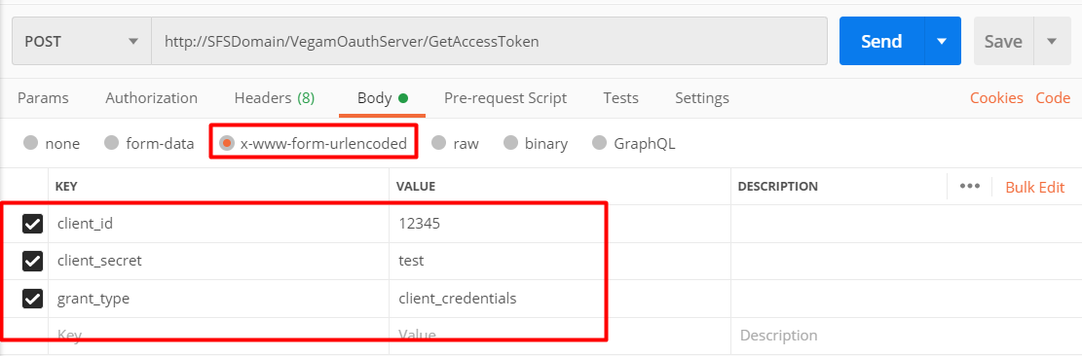

Web service output:
Output will be JSON response with access token as one of the parameters which need to be used for accessing AMS solution API.

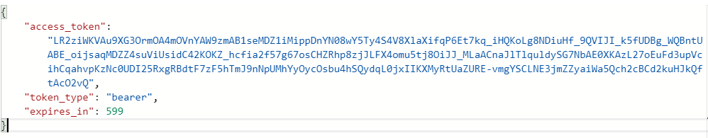

In case of error below information with ErrorCode will be displayed
ErrorCode Information:
Error Code | Description
0001 | Invalid client info
0002 | Error while processing request
{
"error": "",
"error_description": ""
}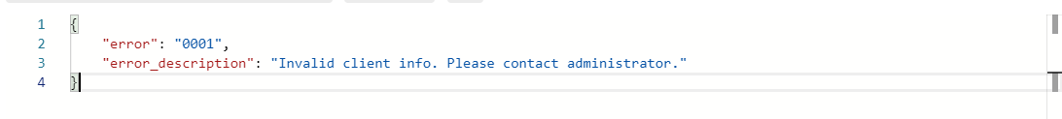

API Specifications
API is required to be developed to successfully integrate QCLAD with Vegam SmartFactory solution. API will need to be developed and exposed by Vegam SmartFactory solution, as explained in the table below.
# | API Name | Description | Hosted On | Type
2 | UpdateSampleQualityInfo | Insert / Update Sample label quality details into SmartFactory solution | Vegam Domain | Push

The API specifications is elaborated in the below sections.

UpdateSampleStatus
This API is invoked by QCLAD whenever they are starting the the sample for testing
Web service URL to access vegam test server:
https://sfs-ap-test.henkelgroup.net/ VegamOauthServer/api/data/UpdateSampleStatus
Web service URL to access vegam production server:
https://ap-hipas.henkelgroup.net/ VegamOauthServer/api/data/UpdateSampleStatus
Web service Type: POST
Web service input parameters :
{
"SampleType": "IPQC",
"SampleLabelNumber": "371584",
"PlantCode": "0799",
"SampleStatus": "IN_PROGRESS",

}

UpdateSampleQualityInfo
API will accept agreed JSON structure; details are as below.
Web service URL to access vegam test server:
https://sfs-ap-test.henkelgroup.net/ VegamOauthServer/api/data/UpdateSampleQualityInfo
Web service URL to access vegam production server:
https://ap-hipas.henkelgroup.net/ VegamOauthServer/api/data/UpdateSampleQualityInfo
Web service Type: POST

Web service input parameters for IPQC:
{
"SampleType": "IPQC",
"SampleLabelNumber": "371584",
"ProcessOrder": "001004172754",
"BatchNumber": "0007447212",
"MaterialNumber": "1392015",
"MaterialDescription": "Liquid Detergent Lavender",
"PlantCode": "0799",
"ActivityNumber": "0023",
"AampleApprovalRejectedTime": "YYYY-MM-DD HH:mm:ss", //plant time zone
"OperatorName": "John Doe",
"QCSampleResult": "Pass", //Pass or Reject
"AdjustMaterials": [
{
"MaterialNumber": "123456",
"BatchNumber": "BT01XZSH",
"Quantity": 10,
"UOM": "KG",
"StorageLocation" : "ST01"
}
],
"ConsesssionRelease": false, //true or false
"ResampleRequired": false, //true or false
"Remark": "",
"QCLabItemResultList":[{
"InspectionLot":"1234567890",
“InspectionCharNumber":"0020",
"MasterInspectionCharacteristics":"00000069",
"InspectionCharacteristicsText":"TENSILE LAP-SHEAR STRENGTH",
"InspectionMethod":"00595101",
"InspectionMethodText":"Shear Strength-Block Specimens",
"LowerSpecLimit":254.5,
"UpperSpecLimit":290.6,
"DecimalPlace":1,
"MeasureUnit":"N/mm2",
"ResultRecordType":"N", //can be N-Numeric or O-Options
"Result":"275.7", //if result is type is N then decimal result as string else pass/fail
"Comments":""
}
]
}

Web service input parameters for JIT:
{
"SampleType": "JIT",
"SampleLabelNumber": "0000216316",
"BatchNumber": "A1233",
"MaterialNumber": "383743",
"MaterialDescription": "Adeka Hardener EH 4070 S",
"PlantCode": "0799",
"SampleApprovalRejectedTime": "YYYY-MM-DD HH:mm:ss", //plant time zone
"OperatorName": "John Doe",
"sampleStatus": "Approved", //Approved or Rejected
"remark": ""
}

Above parameter should be passed in JSON format.

Web service output:
API will return an object as return details.

Return_Info Object Details:
Parameter Name | Description | DateType
ReturnCode |  | Varchar
Description |  | Varchar

Return Code Info
Return Code | Description | Action By QCLAD
0001 | Success | No Action
0002 | API Authentication Error | Correct Authentication and Resend
0003 | Invalid Sample Number | Correct sample number and Resend
0004 | Invalid date time format | Correct the data and Resend
0005 | Invalid JSON | MES Will take care further process
0006 | Estimated Completion time is passed | MES Will take care further process

Note: In the event of any network failure, QCLAD should resend the data to ensure successful processing.

